The S-Matrix and Feynman Diagrams
  - Prologue 9 of Quantum, Actually, Volume 2: A QED Course
Lothar J. Musiol

The engineer's in-and-out waves are the same idea as ⟨f|S|i⟩: arrows from in to out. A Feynman diagram is a recipe for one of those arrows, built from Prologue 5's three actions. Add the recipes, then square

First edition, 2026

How to use this prologue
If you have ever used a network analyzer, you already own half of particle physics. A two-port has incoming waves a₁, a₂ and outgoing waves b₁, b₂, packed as b = Sa; the numbers S₁₁, S₂₁ are arrows, and their squared lengths are reflected and transmitted power. QED uses the same packing for particles: an in-state |i⟩, an out-state |f⟩, a matrix S, an arrow ⟨f|S|i⟩. The first half of this prologue is that dictionary. The second half is a long, slow explanation of Feynman diagrams, the pictures of Prologue 5 used as recipes for ⟨f|S|i⟩: if you have never seen one, or have and they still feel like magic, you are the intended reader. Lesson 50 later turns each picture into exact factors such as ieγ^{μ}. Draw every figure with your own pencil, and do not skip the section on illegal diagrams: spotting a fake is half the skill. Expect eight to twelve hours.

Learning objectives
- Write b = S a for a two-port and name S₁₁ as reflection, S₂₁ as transmission.
- Identify |S_{ij}|² with Prologue 1's probability (power, in the microwave case).
- Write the QED S-matrix element as ⟨f|S|i⟩ and compare it to S₂₁.
- Translate Prologue 2's glass into S-parameters.
- State what a particle-physics "port" is: a species, a momentum, and a spin.
- Recognize a straight line as "electron goes" and a wavy line as "photon goes."
- Recognize a vertex as the only place lines may join: two electron lines and one photon line.
- Read a diagram left to right as a sequence of the three actions, then as one product of factors.
- Count vertices to know the order in the small coupling.
- Distinguish external lines (real particles, in or out) from internal lines (virtual, not detected).
- Write, in words, the two Compton cartoons and why both are required.
- Draw Møller scattering and e⁺e⁻ annihilation as the same marks rearranged.
- State the reading rule: add every allowed cartoon, then square, never square then add.
- List what a diagram is not: a path in a bubble chamber, a time-lapse photo, a proof by itself.

Notation and conventions
Symbol | Meaning
a₁, a₂ | Incoming wave amplitudes at ports 1 and 2 (microwave)
b₁, b₂ | Outgoing wave amplitudes
S₁₁, S₂₁ | Reflection at 1; transmission from 1 to 2
⟨f|S|i⟩ | QED amplitude from in-state i to out-state f
ℳ | The interesting part of S after removing "nothing happened" and a momentum δ-function, Lesson 50
straight line | Electron (or positron) goes, Prologue 5
wavy line | Photon goes
dot, vertex | Electron emits or absorbs a photon
external | A line that ends on a real in or out particle
internal | A line that begins and ends on vertices; not detected
tree | A cartoon with no closed loop
loop | A closed road of internal lines

1 The two-port you already know
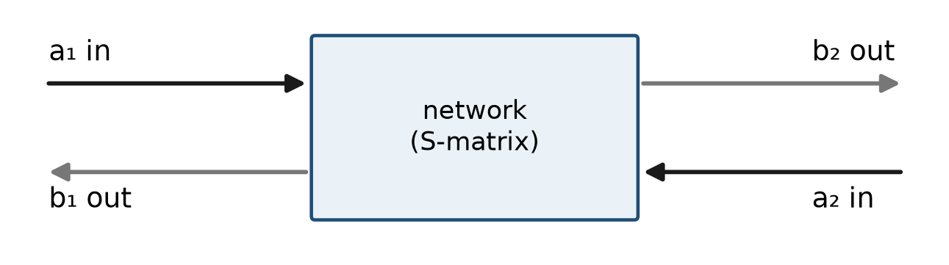
Figure P9.1. A two-port network: incoming waves a₁, a₂ and outgoing waves b₁, b₂, related by b = Sa.
$$b_{1}=S_{11} a_{1}+S_{12} a_{2}$$
$$b_{2}=S_{21} a_{1}+S_{22} a_{2}$$
S₁₁ is "in at 1, back out at 1": reflection. S₂₁ is "in at 1, out at 2": transmission. If the network is lossless, the outgoing power equals the incoming power: the S matrix is unitary, which in arrows says lengths are preserved. That is Prologue 6's ⟨ψ|ψ⟩=1, written for waves on cables.
Worked example 1
A matched load has S₁₁=0: nothing comes back. A short has S₁₁=−1: everything comes back, arrow reversed. A piece of glass, Prologue 2, is a two-port for photons: S₁₁~0.2 (one surface), and |S₁₁|²≈0.04. Two surfaces make S₁₁ a sum of two arrows, thickness-dependent. You have been computing S-parameters with Feynman arrows since Prologue 2.

2 Particles instead of cables
In QED the "cables" are beams. An in-state |i⟩ names every incoming particle: species, momentum, spin. An out-state |f⟩ names every outgoing one. The amplitude is
$$⟨ f|S|i ⟩$$
Read it as S₂₁, with port 1 = the prepared beam and port 2 = the detector setting. If nothing happens, S acts as 1: ⟨f|i⟩, which is zero unless f is i. Scattering is the extra piece, written i(2π)⁴δ⁴(P_{f}−P_{i})ℳ in Lesson 50. ℳ is the S-parameter after you have stripped off "the beam missed" and "momentum must balance."

3 Unitarity is probability accounting
Microwave: if 1 watt goes in, 1 watt comes out of a lossless two-port, in some mix of b₁ and b₂. QED: if a photon goes in, the sum of |⟨f|S|i⟩|² over all possible f is 1 (on the energy shell, with the usual continuum caveats of Lesson 51). Lost probability is a missing diagram, a missed port. Optical theorem, later, is this sentence differentiated.

4 Many ports
A 2→2 process (two particles in, two out) is a four-port if you count each particle's momentum as a port. Compton is S from the port "electron+photon in" to the port "electron+photon out." Annihilation is a different routing: electron+positron in, two photons out. The Feynman diagram of Prologue 9 is the picture of which internal cables you soldered. The S-parameter is the number that picture evaluates to.

5 The only three marks you need
Forget art. You are allowed three marks.
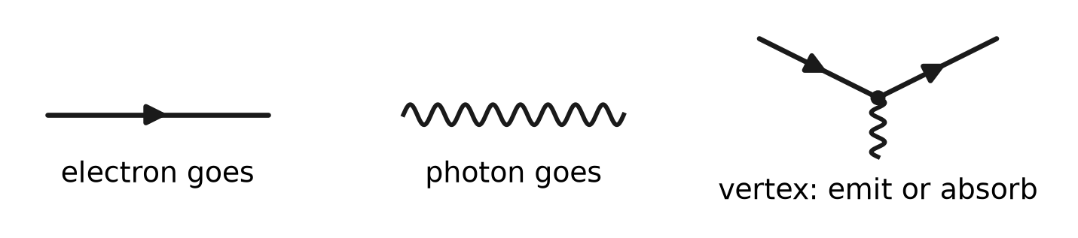
Figure P9.2. The only three marks: a straight line with an arrowhead (an electron goes), a wavy line (a photon goes), and a dot where one wavy line meets two straight lines (a vertex).
That is the whole alphabet. If you ever see four lines meeting at a point in this course, you have drawn a mistake: QED has no four-photon vertex and no four-electron vertex. Gravity would; we are not doing gravity. The strong force has a three-gluon vertex; we are not doing that either. Here, a vertex is always "electron emits or absorbs a photon," which is three lines: two straight, one wavy.
Worked example 3
Can two wavy lines join a straight line with no second straight line? No. The vertex is "electron emits or absorbs a photon." Absorbing, the electron is still an electron: two straight, one wavy. There is no "photon turns into an electron" vertex without a positron (a second straight line, Lesson 23). Charge is conserved at every dot. That is not a slogan. It is which marks are legal.
Worked example 4
Can two straight lines join with no wavy line? No. That would be "two electrons touch and something happens with no photon." QED has no such action. Electrons talk only by exchanging photons (or by being the same electron going). If you want two electrons to scatter, you must draw a photon connecting them.

6 A useless analogy that actually helps
Think of a cooking recipe, not a movie.
- The ingredients listed at the top are the external particles: what you put in the pot and what you take out. A detector could, in principle, catch them.
- The steps in the recipe are the vertices: emit, absorb.
- The sauce you never serve — the intermediate that exists only inside the pot — is an internal line. Nobody plates it. It is still how the dish happened.
A Feynman diagram is the recipe, not a photograph of the kitchen. Two different recipes can produce the same plated dish. If the diner cannot tell which recipe you used, you add the arrows for both recipes, then square.
A subway map is the same idea. The map is not the city. The map tells you which lines connect which stations. An internal line is a tunnel with no station the passenger is allowed to get off at.

7 How to look at the page
People argue about time pointing up or to the right. This course, matching Lesson 50, draws the process as incoming on the left and outgoing on the right when it can, and does not fuss if a figure is rotated. What matters is labels:
- Incoming electron: a straight line with an arrow toward the first vertex, labelled e⁻(p).
- Outgoing electron: a straight line with an arrow away from the last vertex, labelled e⁻(p′).
- Incoming photon: a wavy line toward a vertex, γ(k).
- Outgoing photon: a wavy line away, γ(k′).
The small arrow drawn on an electron line is charge flow, not "the direction of time" in a philosophical sense. A positron is a straight line with the charge arrow reversed (Lesson 23). You may ignore positrons until that lesson, except to know they are legal marks and that an electron line with the arrow pointing the "wrong" way relative to left-to-right is how this course will later draw a positron.
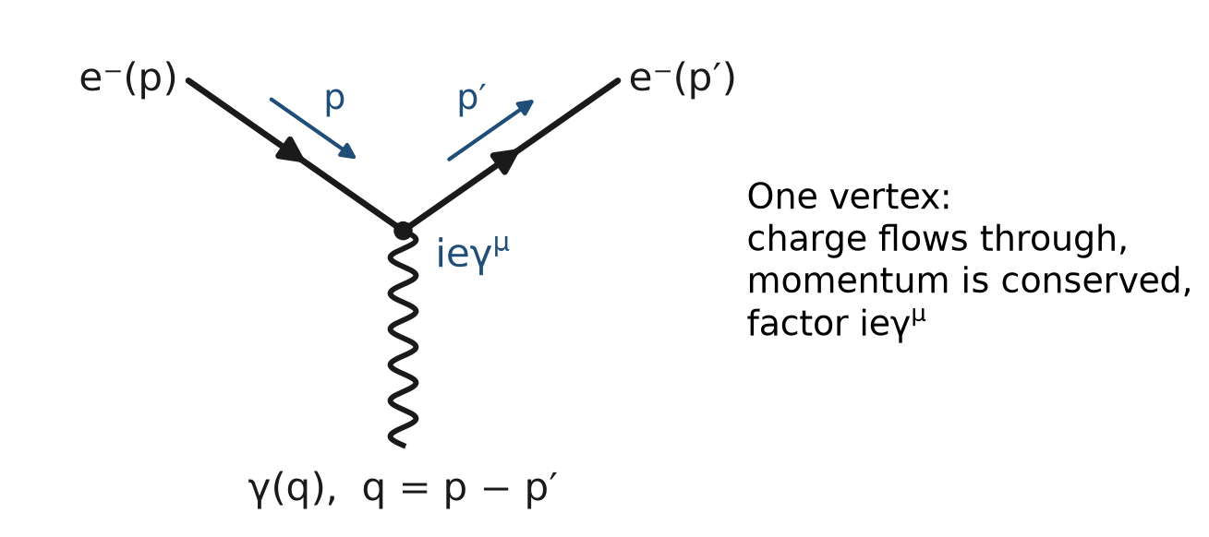
Figure P9.3. One vertex, read left to right: an electron comes in with momentum p, absorbs or emits the photon, and leaves with p′.
That one-vertex cartoon is not a finished scattering process: one incoming electron plus one incoming photon becoming one outgoing electron leaves energy and momentum unmatched for real, on-shell particles (Lesson 45). It is still the legal piece. Compton, below, uses two such pieces glued by an internal electron.

8 Walk a diagram the way you walk a sentence
Take any cartoon. Read it as English before you read it as math.
Example sentence for a two-vertex Compton cartoon:
"An electron comes in. A photon comes in. At the first dot the electron absorbs that photon. The electron goes (internal). At the second dot the electron emits a photon. The electron leaves. The new photon leaves."
If you can say that sentence, you have read the diagram. The later algebra is that sentence with a factor written for each clause.
Order of reading on the page (left to right) is a convenience. Nature does not print a page. What is physical is: these external particles, these vertices, this pattern of connections.

9 External versus internal: the one idea that saves you
An external line sticks out of the cartoon and is labelled with a real particle that a detector could in principle catch. It is on the mass shell: for an electron, E² − |p|² = m²; for a photon, k² = 0.
An internal line is a segment between two vertices. Nobody catches it. It is a way of saying "the three actions happened twice, connected." Its momentum is whatever conservation at the dots forces. It is allowed to be off shell: k² need not equal 0, p² need not equal m². That is what "virtual" means. Not fake. Not imaginary in the i sense. Just not a detected, on-shell particle.
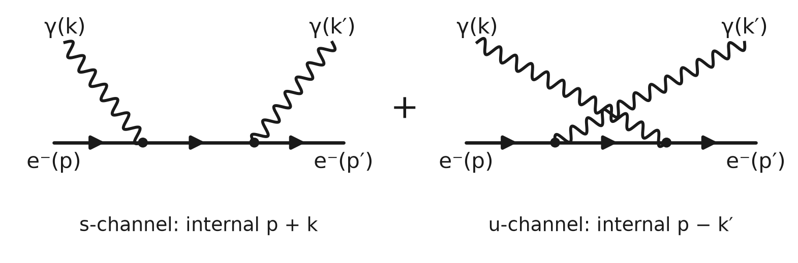
Figure P9.4. Four external lines (two electrons, two photons), two vertices, and one internal electron line between them. The two diagrams are the two orderings of Compton scattering.
In Figure P9.4 every wavy line is external: the photons come in and go out. The only internal line is the electron segment between the two dots. Which line is internal depends on the labels, never on the shape: never trust an unlabelled scribble.
Here is the same idea drawn as electron-electron scattering (Møller): two electrons in, two electrons out, one internal photon.
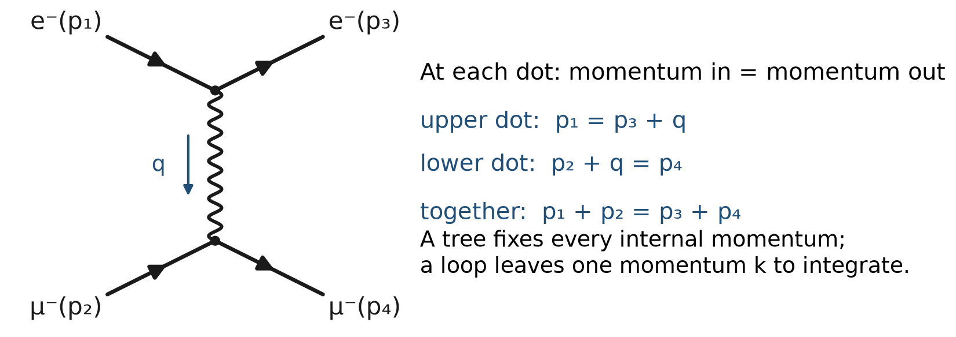
Figure P9.5. Electron–electron (or electron–muon) scattering by one internal photon: the momentum bookkeeping at each dot.
Four external electron lines. Zero external photons. One internal photon. Two vertices. That is "they scattered by exchanging a photon."
Worked example 5
Is the internal line optional decoration? No. If you omit it you have two vertices that are not a process: you have not said how the two electrons knew about each other. The internal line is the photon-goes action connecting them. Rutherford's 1/t is that internal photon going nearly on shell in the t-channel (Lesson 61).
Worked example 6
A student says "virtual particles are particles that exist for a time Δt ~ 1/ΔE allowed by the uncertainty principle." That slogan is a mnemonic, not a law used in this course. The calculation never integrates a lifetime. It integrates a momentum. Virtual means: internal line, off shell, not detected. Keep the slogan if it helps you remember off-shell; throw it away if it makes you picture a tiny real photon hiding between the dots.

10 A vertex is a number, a line is a number
Each mark will become a factor in Lesson 50. You do not need the formulae yet. You need the habit: the cartoon is a product of factors, hence one arrow.
- Vertex: +ieγ^{μ}, size of order e ≈ 0.3, so α = e²/4π ≈ 1/137. Feynman's easy lectures called the electron-photon coupling a small number of order 0.1; this course's α is that smallness made precise.
- Internal electron: the electron-goes factor, S_{F}, Lesson 47.
- Internal photon: the photon-goes factor, D_{μν}, Lesson 48.
- External electron: a spinor u or ū, Lesson 52.
- External photon: a polarization ε, Lesson 52.
Two cartoons: two arrows. Add them. Then square.
Counting powers: each vertex brings one e. Two vertices: e², which is one power of α up to 4π. Four vertices: e⁴ ~ α², a loop or a more elaborate tree. Smaller, usually. That is why this course computes trees first.
Worked example 7
A diagram with three vertices: is it allowed? Yes as a drawing, if each vertex is two-straight-plus-one-wavy. For an ordinary 2-to-2 process (two particles in, two out) you cannot make a connected cartoon with an odd number of vertices while keeping charge and the photon count consistent in the simple cases of this prologue. You will see even vertex counts in Compton, Møller, and annihilation at the first interesting order. If you draw three vertices for Compton, you have added an extra emit-and-absorb that belongs to a higher-order correction. Legal, smaller, later.

11 Conservation at a dot, like traffic at a T-junction
At every vertex, four-momentum is conserved: what flows in equals what flows out.
$$p_{in}+k_{in}=p_{out} \left(absorb a photon\right),p_{in}=p_{out}+k_{out} \left(emit a photon\right) Charge is conserved because the marks already force it \left(two electron lines,one photon\right).$$
For an internal line, you do not get to pick its momentum freely once the externals and the other internals are fixed: the dots decide. In a tree, every internal momentum is determined by the externals. In a loop, one momentum around the loop is not determined; you will integrate it (Lesson 62). That is the only reason loops are harder. Not mysticism. An unfixed k.

12 Compton, drawn slowly
Process: electron in, photon in; electron out, photon out. External lines: e⁻(p), γ(k), e⁻(p′), γ(k′).
You need two cartoons at the first interesting order (two vertices, one internal electron).
Cartoon A, "absorb the incoming photon first, emit the outgoing photon later":
Figure P9.6. Compton scattering. Left: the incoming photon is absorbed first. Right: the outgoing photon is emitted first. Both diagrams are required.
Sentence: photon in is absorbed; the electron goes virtually; photon out is emitted.
Cartoon B, "emit the outgoing photon first, absorb the incoming photon later":
Sentence: photon out is emitted first; the electron goes virtually with a different internal momentum; photon in is absorbed.
Why both? Because the three actions do not care which photon is "the incoming one" attached first. The experiment cannot tell the two orders apart. Undistinguished ways: add arrows (Prologue 1). Squaring only A, or only B, gives a wrong |S|².
Lesson 57 computes the sum and finds a miracle: the interference between A and B vanishes in the massless limit, leaving −2e⁴(s/u + u/s). You are not asked to believe the miracle. You are asked to keep both cartoons. The miracle is a result, not a reason to drop B from the start.
Worked example 8
Could there be a cartoon with an internal photon instead, for Compton? That would be: electron emits a photon that becomes the outgoing photon while the incoming photon... no. Compton's external particles are one electron and one photon on each side. The two-vertex connected cartoons that do that are A and B above, with an internal electron. A cartoon with an internal photon and four external lines of the Compton type is a different process or a disconnected doodle. Draw it; you will find you have changed who is in and who is out.

13 Møller, drawn slowly
Process: two electrons in, two electrons out. No photons in the initial or final list. They still scatter, because they exchange a photon that nobody detects.
Cartoon (t-channel exchange):
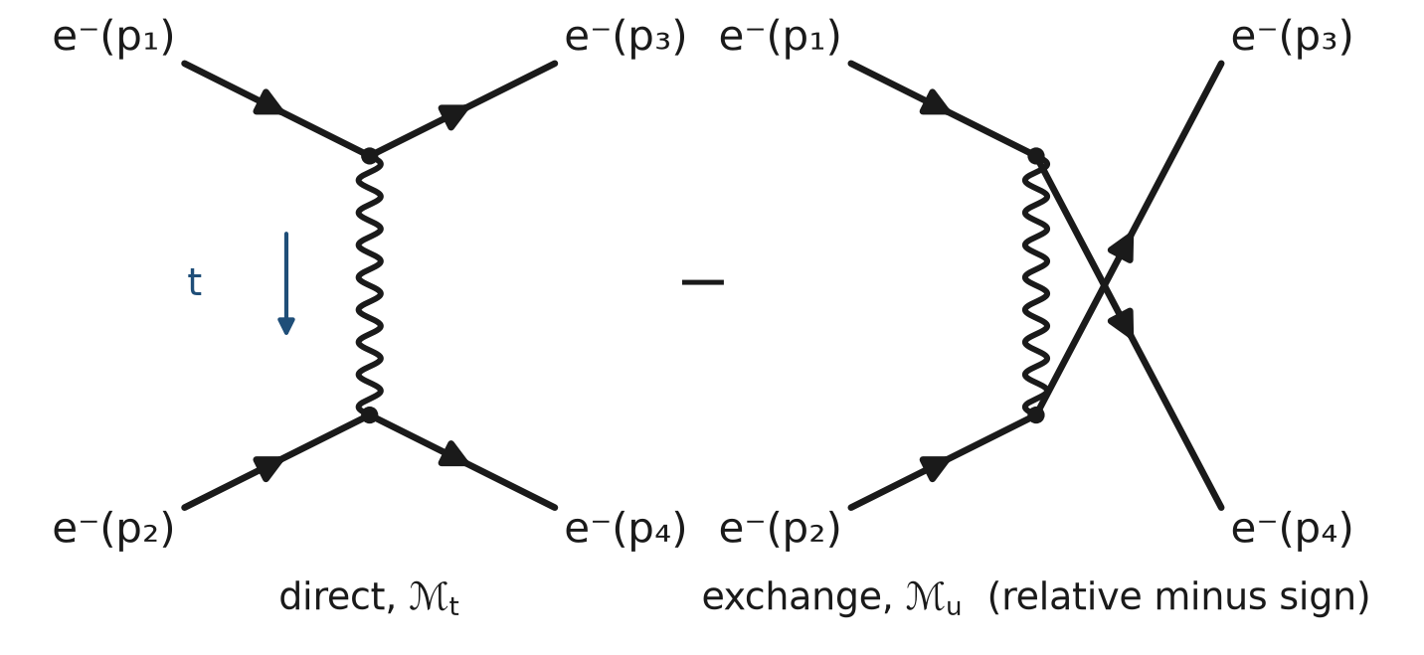
Figure P9.7. Møller scattering: two identical electrons, two diagrams, a relative minus sign (Prologue 5, Section 4).
There is a second cartoon (u-channel): the outgoing labels p3 and p4 swapped, because the two outgoing electrons are identical and you cannot say which incoming electron became which outgoing one. Identical fermions: add with a minus (Lesson 34, Lesson 55). This prologue only needs: two cartoons again, because the particles are indistinguishable. Add, then square.

14 Annihilation and pair production: the same marks, rotated
e⁺e⁻ → γγ (annihilation to two photons):
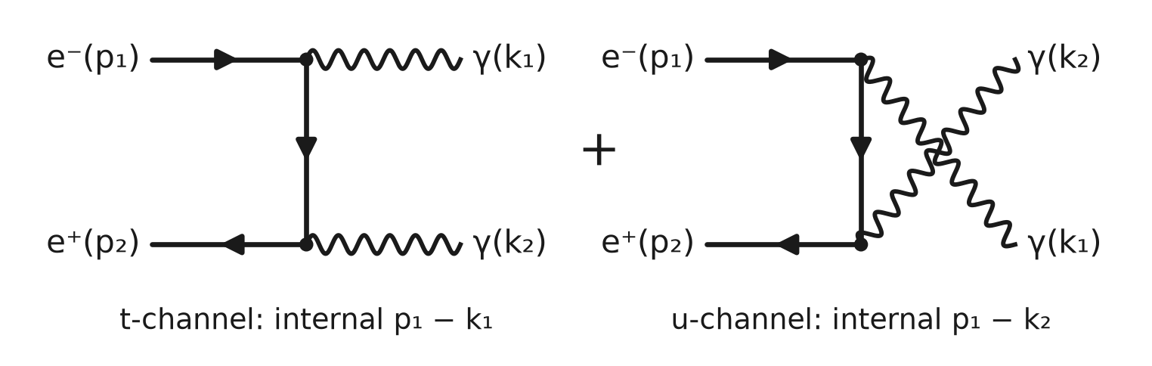
Figure P9.8. Electron–positron annihilation into two photons: the Compton marks rotated.
Plus the cartoon with the two photons swapped.
γγ → e⁺e⁻ is the same picture with "in" and "out" reversed: pair production by two photons. One real photon in empty space cannot do it (q² = 0, pair needs s ≥ 4m²). Two photons can. An external field can (Lesson 86).
The idiot-proof slogan: crossing means you rotate which lines are incoming and outgoing; the marks stay legal. Lesson 53 will name s, t, u as the invariants that make those rotations precise.

15 Trees and loops, without panic
If the cartoon can be drawn on a page without any closed road, it is a tree. Compton at this order is a tree. Møller at this order is a tree. Trees have every internal momentum fixed by the externals.
If a photon is emitted and later absorbed on the same electron line, you have drawn a loop.
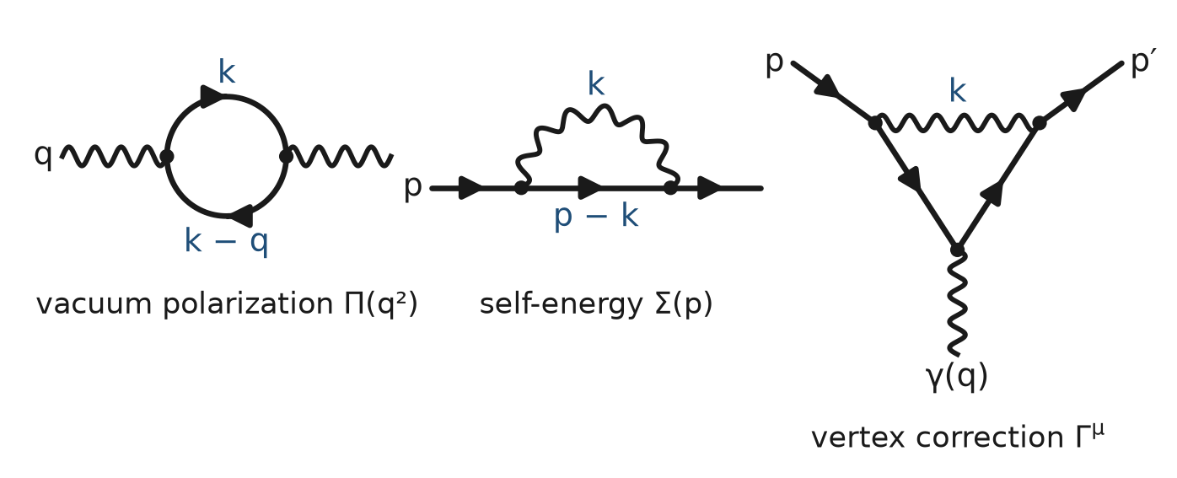
Figure P9.9. The three one-loop building blocks: a photon briefly becoming a pair (vacuum polarization), an electron emitting and reabsorbing a photon (self-energy), and a photon spanning a vertex (vertex correction).
The middle picture of Figure P9.9 is the electron self-energy (Lesson 64). The electron that enters and the electron that leaves are still external if they hit a detector. The loop is an insertion on the line. It shifts the mass; Lesson 68 absorbs the shift into m₀.
The left picture is a photon line with an electron circuit sitting on it. That is how the charge runs with q² (Lesson 69). A loop is extra vertices, hence extra factors of e, hence smaller at ordinary energies, and it needs an integral over the unfixed loop momentum (Lesson 62). Trees first. Loops in Part IX. Anyone who tells you QED "is all loops" is skipping the part you can compute with a pencil this year.

16 One Feynman diagram is already several time-orderings
Cartoon A for Compton is one Feynman diagram. If you insist on a movie with a clock, "absorb then emit" and the internal electron going forward in time is one movie; there are related movies once positrons are allowed. The Feynman diagram adds those movies for you. That is why one diagram is allowed to look as if "the photon was emitted before it was absorbed" without anyone owing you a time machine. The diagram is not a timeline. It is a term.
If you need a clock picture, draw two time-ordered graphs and add them. If you are willing to let Lesson 47's propagator do that sum, draw one Feynman diagram. This course draws Feynman diagrams.

17 Illegal cartoons, so you can spot them
- A photon line that splits into two photon lines and nothing else: not QED. (A photon does not decay into two photons at a point.)
- Two electrons annihilating into one photon as a finished process: forbidden on-shell (Lesson 45). You may draw it as a piece of a larger cartoon; you may not stop there.
- A vertex with two photons and no electron: not QED.
- A vertex with four electron lines and no photon: not QED.
- Crossing electron lines without a vertex and calling it an interaction: those electrons missed each other; that is the "1" in S = 1 + iℳ, nothing happened.
- Drawing a bubble-chamber helix and labelling it "the Feynman diagram for that event": a track is many real ionizations, each a detected photon-or-atom interaction. A diagram is one term in a sum of arrows for a specified in and out.

18 What a first reading may skip
Spin, γ-matrices, iε in the propagator, gauge fixing, minus signs for closed fermion loops, ghost stories from other theories. All real, all later. If you can look at a Compton page and say "two vertices, one internal electron, two cartoons, add then square," you have passed this prologue. Lesson 50 is the same sentence with the factors filled in.

Connections to QED
Result of this prologue | Where it is used
b=Sa | Laboratory language for ⟨f|S|i⟩
S₁₁, S₂₁ | Reflection and transmission; Prologue 2's glass
ℳ | Lesson 50–51, the computed S-parameter of a process
Unitarity | Probability; later, the optical theorem
Three marks | Prologue 5; Lesson 50 recipe
External vs internal | Virtual photons, Lesson 48; Lesson 61 poles
Two Compton cartoons | Lessons 50 and 57
Møller exchange | Lesson 55
Annihilation cartoons | Lesson 56
Add then square | Prologues 1–2, 8; Lesson 51
Loops as extra dots | Lessons 62–69, 76

Summary
- S-parameters are arrows from in-waves to out-waves.
- |S_{ij}|² is power in the microwave, probability in QED.
- ⟨f|S|i⟩ is the same idea for particles.
- Glass was an S₁₁. Compton is a bigger S.
- Lesson 51 converts |ℳ|² into a cross section, the particle version of |S₂₁|² times a flux.
- Straight = electron goes. Wavy = photon goes. Dot = vertex. Only two-straight-plus-one-wavy dots are legal.
- A diagram is a recipe for one arrow, not a photograph of a collision.
- External lines are real on-shell particles; internal lines are virtual cables, off shell, not detected.
- Each cartoon is one arrow. Add every undistinguished cartoon, then square.
- Compton needs two cartoons (internal electron). Møller needs exchange cartoons (internal photon). Annihilation is the same alphabet rotated.
- Trees first. Loops are extra dots plus an unfixed momentum. Lesson 50 writes the numbers.

Exercises
No | Problem
1 | Core. What is S₁₁ in words? S₂₁?
2 | Core. A lossless matched line: quote S₁₁ and S₂₁.
3 | Core. Write the QED sandwich that corresponds to S₂₁.
4 | Core. Map Prologue 2's single glass surface onto an S-parameter.
5 | Core. What does unitarity say in one sentence?
6 | Core. What does Lesson 50 strip off S to leave ℳ?
7 | Core. Is a decay Γ an S-parameter?
8 | Challenge. Three-port, one in, two out (a decay into two particles). Which S-column is the physics?
9 | Core. Draw the three legal marks and write the English sentence for each.
10 | Extension. Why is a four-line vertex illegal in QED?
11 | Extension. In one sentence, what is a virtual line?
12 | Core. Why must Compton's two cartoons be added before squaring?
13 | Core. Count vertices, external lines, and internal lines on Møller (two electrons in, two out, one photon exchanged).
14 | Extension. Is a bubble-chamber track a Feynman diagram? Say why in two sentences.
15 | Core. What S-parameter is a diagram computing, in the first half of this prologue's language?
16 | Extension. Draw, as words or marks, e⁺e⁻ → two photons, including the crossed cartoon.
17 | Extension. Why can a single on-shell photon not become e⁺e⁻ by itself?
18 | Challenge. A loop on an external electron. Is the electron that hits the detector still external? What later lesson names the loop?
19 | Extension. A student draws two wavy lines meeting two wavy lines at a point and calls it photon-photon scattering at tree level in QED. What is wrong, and what would a legal QED cartoon for γγ → γγ need?
20 | Extension. For Compton cartoon A, write the four-momentum at each vertex in terms of p, k, p′, k′.
21 | Core. How many powers of e does a two-vertex tree carry? How many does a one-loop self-energy insertion on an electron line carry?
22 | Extension. Distinguish charge-flow arrows on electron lines from "time points to the right." Give one sentence for a positron.
23 | Extension. Why does adding a disconnected "nothing happens" electron line next to a photon-goes line not describe Compton scattering?
24 | Challenge. Two electrons in, two electrons out, two internal photons, four vertices, a box. Is that a tree? What process is it a correction to?

Solutions
Attempt each exercise before reading its solution. If you are stuck, read only the first sentence of the solution, then try again.
1. S₁₁: reflection at port 1. S₂₁: transmission from 1 to 2.
2. S₁₁=0, S₂₁=e^{iθ} with |S₂₁|=1 (a delay).
3. ⟨f|S|i⟩.
4. S₁₁≈0.2, |S₁₁|²≈0.04.
5. Outgoing probability (or power) equals incoming; arrows preserve length in total.
6. The identity piece (nothing happened) and a momentum-conserving δ-function; ℳ is the rest.
7. It is built from |ℳ|² the same way; one "in" port, several "out" ports, no flux factor, Lesson 51.
8. The column for that one incoming state; the two outgoing particles are two ports sharing the row.
9. Straight: electron goes. Wavy: photon goes. Dot: electron emits or absorbs a photon (two straights, one wavy).
10. The only interaction is electron emits/absorbs photon; that is three lines. Four lines at a point would be a different theory.
11. An internal line between vertices, not a detected on-shell particle; its k² or p² need not be the mass-shell value.
12. The experiment does not distinguish the two orders; undistinguished ways add as arrows, then you square the sum.
13. Two vertices, four external electron lines, one internal photon, zero external photons.
14. No. A track is a history of many real ionizations, each already a detected event. A diagram is a term in a sum of arrows for specified in and out particles.
15. A contribution to ⟨f|S|i⟩, i.e. to ℳ.
16. Two vertices; an internal electron connecting them; two incoming fermion lines (electron and positron); two outgoing photons; plus the crossed cartoon with the two photons swapped.
17. One vertex cannot do it, and even with more structure a single real photon has q² = 0 while a pair has s ≥ 4m² (Lessons 45, 58). An external field can, Lesson 86.
18. The line that reaches the detector is still external. The loop is a self-energy insertion, Lesson 64; it is absorbed into m in Lesson 68.
19. QED has no four-photon vertex. Light-by-light scattering at the first legal order is a one-loop box of electrons (four vertices, four internal electron lines). It is not a tree.
20. Absorb vertex: p + k = p_{i}nternal. Emit vertex: p_{i}nternal = p′ + k′. Together p + k = p′ + k′, overall conservation. Cartoon B uses a different internal: p − k′ at the first vertex.
21. Two-vertex tree: e². Self-energy insertion: two extra vertices, so extra e² relative to the bare line, one loop.
22. The arrow on a fermion line is charge flow. Time-to-the-right is a drawing habit. A positron is the same straight line with charge flow opposite to the electron's.
23. Disconnected pieces factor. "Photon goes" beside "electron goes" with no vertex is two separate do-nothings, not Compton. Compton needs the vertices that connect the electron to both photons.
24. A box with a closed road is a loop (two-loop? No: four vertices, four internal lines forming one loop is one loop by L = I − V + 1 = 4 − 4 + 1 = 1). It is a one-loop correction to Møller scattering (or a related 2-to-2 process), not a tree.

Next lesson
Lesson 1 starts the algebra: the arrows of the prologues are complex numbers, now with full rules. The diagrams return as a precise recipe in Lesson 50.

